The Laplace Transform Table

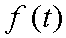 | 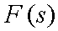
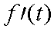 | 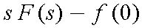
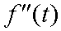 | 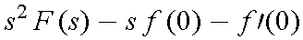
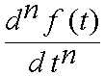 | 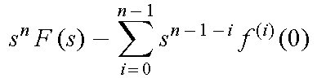
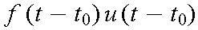 | 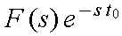
 | 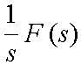
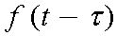 | 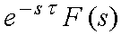
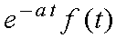 | 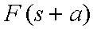
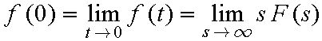
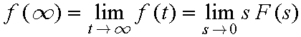
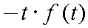 | 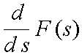
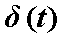
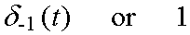
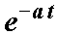 | 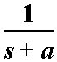
 | 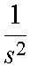
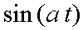 | 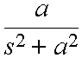
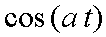 | 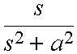

The Laplace Transformation

